**Project Report**Heritage Treasures: An In-Depth Analysis of UNESCO World Heritage Sites using Tableau

**Team Members**

**Team ID:** **LTVIP2026TMIDS49297**

|  |  |
| --- | --- |
| **Team Leader :1** | Chitturi Purna Veera Shanmuja  shanmuch918@gmail.com |
| **Team Member :2** | Harini Jajula  harinijajula777@gmail.com |
| **Team Member :3** | Suravarapu Kushal Kumar  Suravarapukushal5511@gmail.com |
| **Team Member :4** | Tadi Satyaprasanna  Satyaprasanna2356@gmail.com |

**1. INTRODUCTION**

**1 Project Overview**

This project aims to enhance the accessibility and interpretability of global heritage data by transforming static UNESCO records into a dynamic, interactive visual ecosystem. The system enables users to analyze site distributions, compare regional density, and categorize sites into cultural, natural, or mixed designations seamlessly. It provides functionalities for country-specific filtering, year-on-year trend analysis, and identified rankings of nations with the highest heritage site counts. Additionally, the system facilitates a deeper understanding of historical growth through intuitive mapping and cumulative timeline visualizations. With its user-friendly interface and robust data management via Excel and Tableau, Heritage Treasures optimizes the research process, improves data-driven storytelling, and ensures a clear perspective on the preservation of global legacy.

It integrates critical data points like geographical coordinates, inscription years, and site categories into a centralized digital dashboard, reducing the complexity of manual data sorting and improving analytical decision-making through real-time visual insights. By leveraging GitHub for documentation and version control, the project provides a structured and professional framework for exploring and presenting the world's most significant cultural and natural treasures to a wide

audience,

**1.2 Purpose**

The main purpose of this project is to visually analyze UNESCO World Heritage Sites data using Tableau in order to identify trends, patterns, and regional distributions through interactive dashboards. The project focuses on developing an interactive Tableau dashboard that visualizes UNESCO World Heritage Sites by country, region, and category, thereby providing meaningful insights for cultural understanding and tourism analysis.

**2. IDEATION PHASE**

**2.1 Problem Statement**

**Customer Problem Statement :**

**I am...**  
A user who is interested in understanding UNESCO World Heritage Sites and their cultural, natural, and historical significance across different countries and regions.

**I'm trying to...**  
Explore and analyze UNESCO World Heritage Sites data to identify trends, patterns, and regional distributions, and gain meaningful insights for cultural awareness, education, and tourism-related decision making

**But...**  
I often struggle to understand large UNESCO datasets due to scattered information and lack of clear visual representation

**Because...**  
Most available reports are static text heavy and do not provide interactive insights for easy comparision and analytics

**Which makes me...**  
Feel frustrated, uncertain, about interpreting data leading to poor insights delay decisions and d missed opportunities for exploration

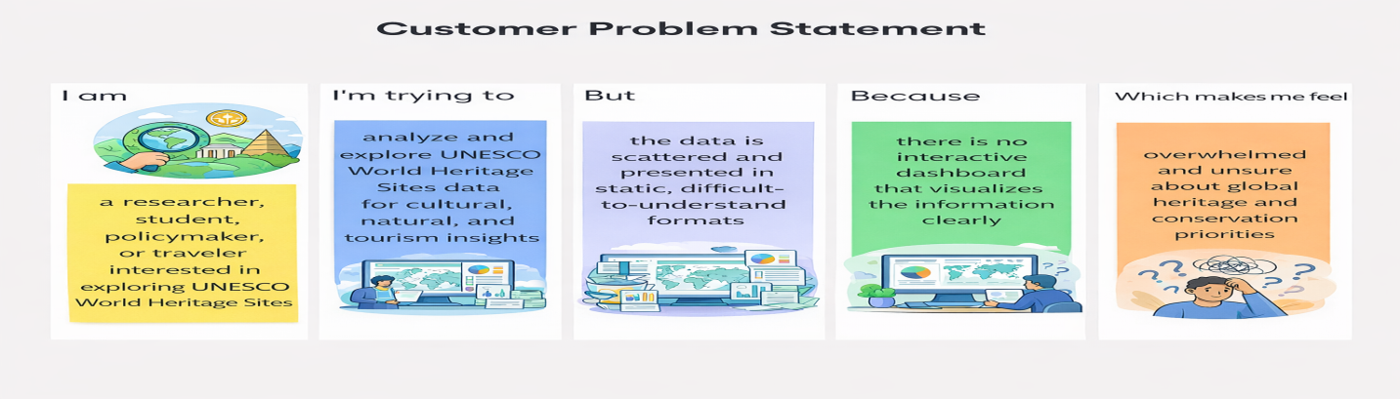

|  |  |  |  |  |  |
| --- | --- | --- | --- | --- | --- |
| **Problem Statement (PS)** | **I am (Customer)** | **I’m trying to** | **But** | **Because** | **Which makes me feel** |
| PS-1 | a tourist analyst | Ientify countries with highest of UNESCO sites | Data is spread across multiple sources | There is no centralized interactive dashboard | Confused and inefficient in decision-making |
| PS-2 | a student/researcher | understand cultural,natural, and mixed heritage sites | The datasets are complex and difficult to interpret | Static reports do not allow dynamic filtering or time based analysis | Hesitant and user informed when planning conservation strategies |

**2.2 Empathy Map Canvas**

**WHO are we empathizing with?**

**Primary Users:**

* Tourism department officials
* Researchers and historians
* Students studying geography and culture
* Travel planners and bloggers
* Cultural heritage organizations
* General public interested in world heritage

**Key Stakeholders:**

* Data analysts using Tableau
* UNESCO authorithies
* Tourism boards
* Heritage conservation organizations

**What do they NEED TO DO?**

* Understand global distribution of UNESCO heritage sites
* Visualize heritage data in an interactive and simple format.
* Identify countries with the highest number of heritage sites
* Analyze categories (cultural, Natural,Mixed).
* Track trends over years of inscription
* Support tourism planning and cultural awareness programs.

**What do they SEE?**

* Large raw UNESCO heritage datasets
* Static or outdated heritage reports
* Uneven distribution of heritage sites across countries
* Growing global interest in cultural tourism
* Needs for simple and interactive visual insights

**What do they SAY?**

* *“We need clear dashboards to understand heritage site distribution.”*
* *“It’s hard to make sense of raw UNESCO data.”*
* *“We want to know insights about cultural and natural heritage sites”*
* *“We need to justify reliable data for tourism planning.”*
* *“We’d like to see visual stories, not just long reports.”*

**What do they DO?**

* Collect heritage-related datasets from public sources
* Prepare manual reports or static charts
* Analyze data using spreadsheets
* Spend time organizing and filtering data
* Share reports with stakeholders for awareness and planning..

**What do they HEAR?**

* From government: *“promote cultural heritage through data insights.”*
* From tourism industry: *“Heritage analytics improves visitor engagement..”*
* From peers: *“Better dashboards save us time.”*
* From consumers: *“We want easy accesss to heritage information.”*

**PAINS**

* Time-consuming data collection and cleaning.
* Lack of interactive user-friendly, heritage visuals.
* Difficulty understanding global heritage distribution.
* Missed tourism opportunities due to delayed insights.
* Inability to clearly present heritage data to stakeholders.

**GAINS**

* Easy-to-use Tableau dashboards to explore heritage trends interactively.
* Faster, clearer decision-making.for tourism planning
* Better comparision of countries and heritage categories
* More innovative, improve cultural awareness and support
* Increased competitiveness in the global heritage sites.

**Solution Statement**

**“This project provides interactive Tableau dashboards to visualize UNESCO World Heritage Sites by region and category. It helps users easily understand heritage distribution and trends through clear data visualization.”**

**Example:**

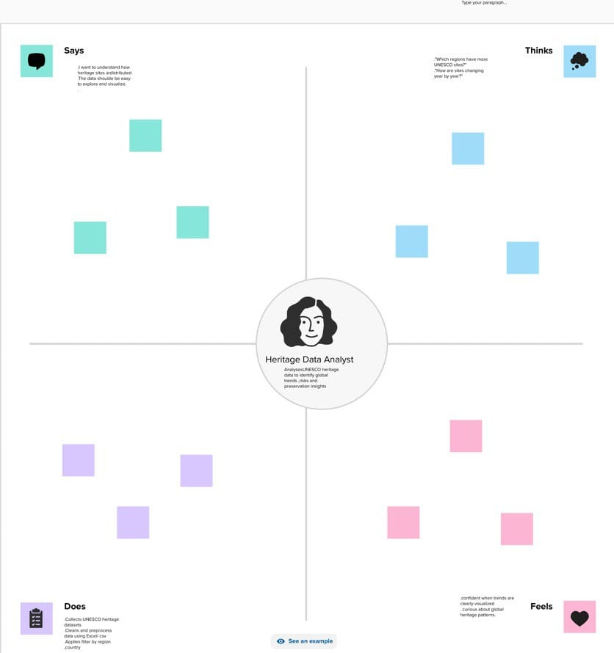

**2.3 Brainstorming**

**Brainstorm & Idea Prioritization:**

World Heritage Sites recognized by UNESCO are globally significant cultural and natural assets. However, the available data is scattered, complex, and presented in static formats, making it difficult for researchers, policymakers, and tourism planners to identify trends, compare regions, analyze endangered sites, and make informed, data-driven decisions.

There is a need for an interactive Tableau dashboard that transforms raw heritage data into clear, visual, and actionable insights.

**Step-1: Team Gathering, Collaboration and Select the Problem Statement**

The first step, our team was formed by gathering individuals with diverse skills and shared interest in data analytics. We collaborated to understand each member's strengths, such as data visualization, research, and communication. After a group discussion and brainstorming session, we shortlisted several potential issues in the cosmetics industry

problem statement: **“Understanding consumer insights and trends related to sensitive skin products”.** This topic was chosen based on current market demand and its relevance to real-world cosmetic usage patterns.

**Team Leader :** Chitturi Purna Veera Shanmuja

**Team member** : Harini Jajula

**Team member** : Suravarapu Kushal Kumar

**Team Member** :Tadi SatyaPrasanna

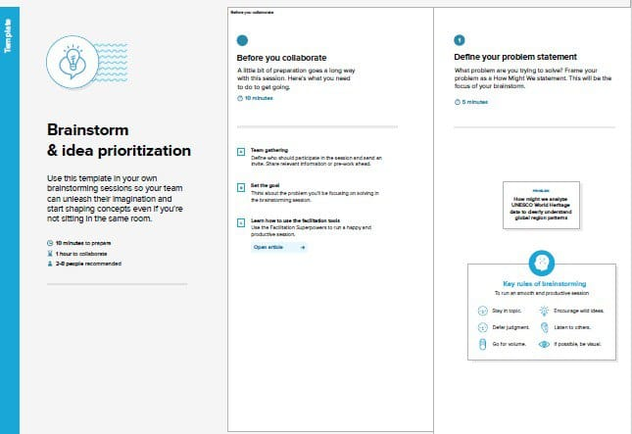

**Step-2: Brainstorm, Idea Listing and Grouping**

In this phase, multiple ideas were brainstormed to explore different ways of analyzing UNESCO World Heritage Sites data. The ideas were grouped based on similar analysis objectives. Idea List Analyze UNESCO World Heritage Sites by category.

Compare heritage sites across regions and countries Identify countries with the highest number of heritage sites Analyze endangered heritage sites. Study year-wise growth of UNESCO heritage sites

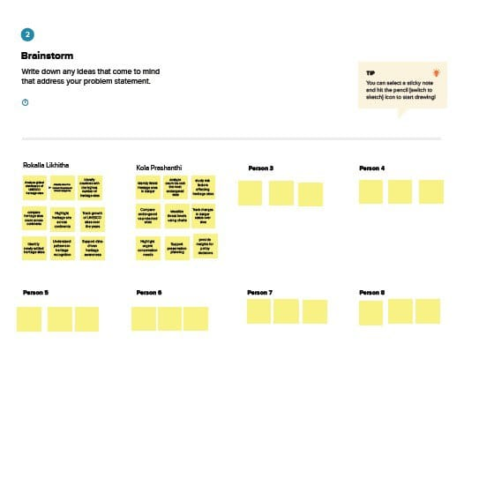

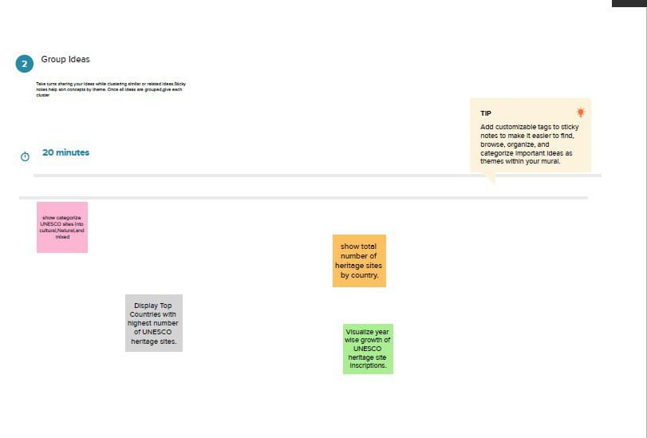

**Step-3: Idea Prioritization**

We prioritized ideas based on user needs, data availability, and project goals. Features like skin type suitability, price comparison, and top product ranking were selected as the most impactful for the dashboard.

**Site Classification Analysis**

* Categorize sites by Cultural, Natural, and Mixed heritage.
* Identify which category dominates globally and regionally.

**Regional & Country Comparison**

* Compare the number of heritage sites across continents (Asia, Europe, Africa, etc.).
* Identify top countries with the highest number of UNESCO sites.

**Endangered Heritage Sites**

* Track sites listed as “World Heritage in Danger.”
* Identify countries with the most endangered sites..

**Year-wise Trend Analysis**

* Analyze how the number of recognized sites has grown over decades.
* Identify peak years of heritage inscription.

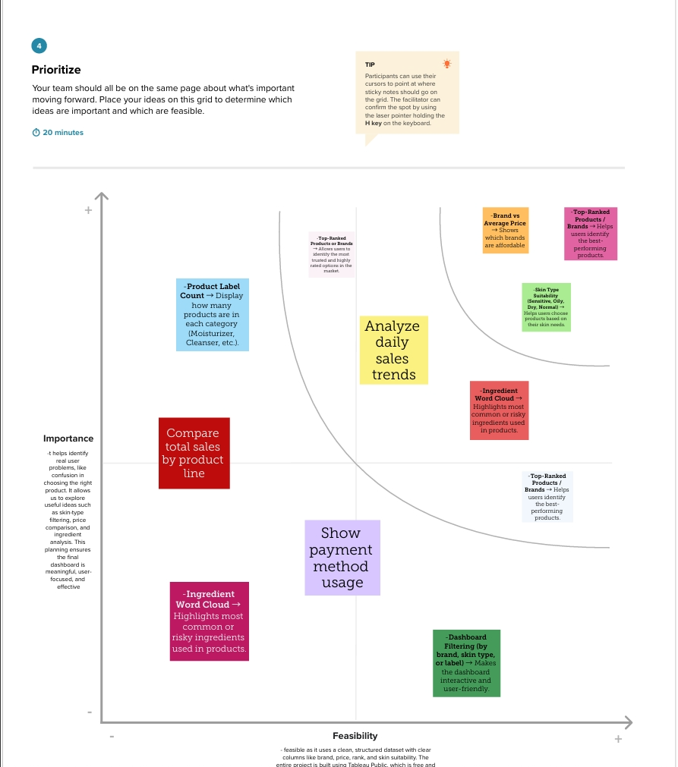

**3. REQUIREMENT ANALYSIS**

**3.1 Customer Journey Map**

[URL for customer journey map](https://drive.google.com/file/d/1UMfKHK45y5AaZaFAd37-xgYHHLMHGBTq/view?usp=drivesdk)

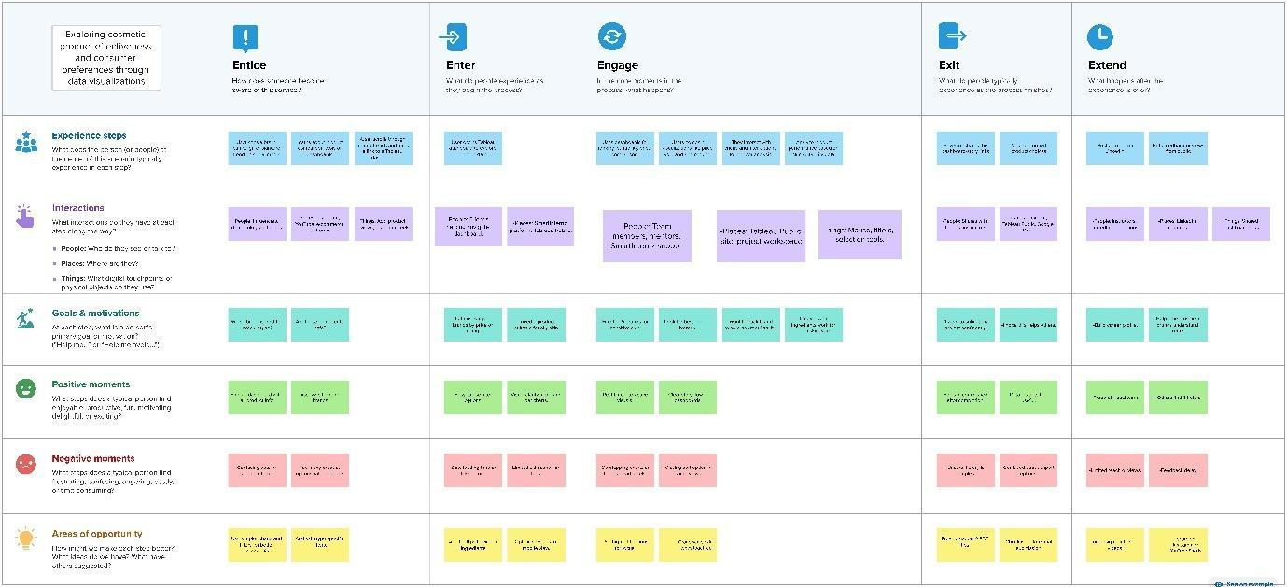

**3.2 Solution Requirement**

**Functional Requirements: Heritage Treasures**

Following are the functional requirements of the proposed solution.

|  |  |  |
| --- | --- | --- |
| **FR No.** | **Functional Requirement (Epic)** | **Sub Requirement (Story / Sub-Task)** |
| FR-1 | Data Collection | |  | | --- | | Collect UNESCO World Heritage Sites dataset from reliable sources (UNESCO/Kaggle | | Collect site details like country, region, category, year | |  | |
| FR-2 | Data Cleaning & Processing | |  | | --- | | Clean raw data (remove duplicates, handle missing values) | | Transform and aggregate data region-wise and category-wise | |
| FR-3 | Data Storage | Store raw dataset securely  Store cleaned and processed heritage data |
| FR-4 | Data Visualization & Analysis | |  | | --- | | Build interactive dashboards in Tableau | | Visualize heritage sites by region, country, category, and year Analyze endangered heritage sites and trends | |  | |
| FR-5 | Alerts & Insights Delivery | |  | | --- | | Provide meaningful insights on global heritage distribution | | Highlight regions and countries with highest heritage concentration | |

**Non-Functional Requirements: Heritage Treasures**

Following are the non-functional requirements of the proposed solution.

|  |  |  |
| --- | --- | --- |
| **FR No.** | **Non-Functional Requirement** | **Description** |
| NFR-1 | **Usability** | Dashboards should be simple, interactive, and easy to understand for users |
| NFR-2 | **Security** | Dataset and project resources should be securely stored and accessed |
| NFR-3 | **Reliability** | Dashboards must display accurate and consistent heritage data |
| NFR-4 | **Performance** | Visualizations should load within acceptable time limits |
| NFR-5 | **Availability** | Tableau Public dashboards should be accessible anytime via shared link |
| NFR-6 | **Scalability** | System should support additional heritage data and future updates |

**3.3 Data Flow Diagram**

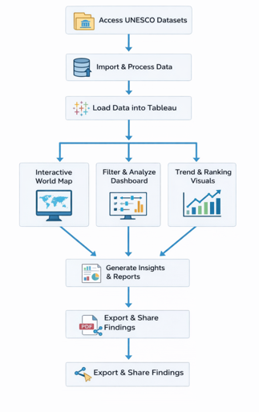

This data flow diagram explains how heritage site data is collected, analyzed, and visualized using Tableau dashboards. The insights help researchers and organizations in heritage preservation and decision-making.

**1. Data Sources Provide Information**

* **Data:** UNESCO World Heritage Sites details (country, region, category, year inscribed).
* **Source:** Kaggle dataset / UNESCO official data.

**2. Heritage Treasures Dashboard (Process)**

* **Actions:**  Collects, cleans, and organizes heritage site data.
* **Tools:** Uses Tableau to create charts, maps, and interactive dashboards.

**3. Output: Insights & Visualizations**

* **Outcome:** Provides interactive visual reports showing site distribution by country, region, and category.

**4. Stakeholders Use Insights**

* **Users::** Researchers, tourism departments, students, and cultural organizations**.**
* **Actions:** Analyze trends and understand global heritage distribution.

**5. Result: Better Cultural Awareness**

* **Outcome:** Helps in promoting tourism, heritage conservation, and cultural awareness.

**6. Feedback Loop**

* **Process:** Data can be updated regularly to reflect newly added heritage sites and trends.

**3.4 Technology Stack**

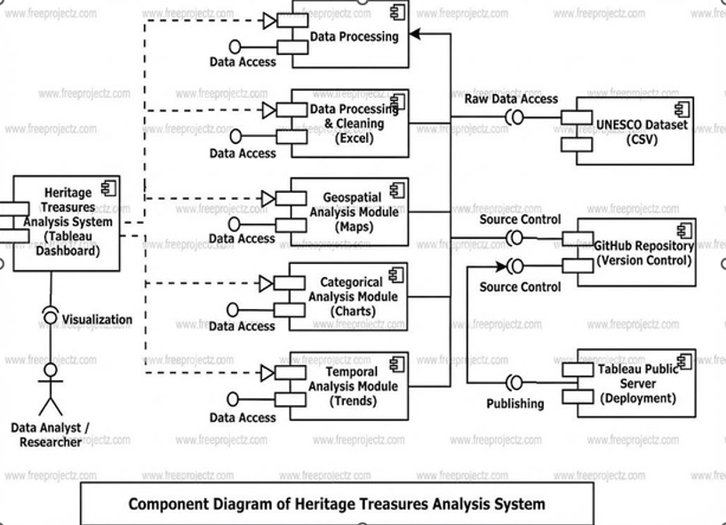

**Technical Architecture**

**Table-1 : Components & Technologies:**

|  |  |  |  |
| --- | --- | --- | --- |
| **S.No** | **Component** | **Description** | **Technology** |
|  | User Interface | Displays interactive UNESCO heritage dashboards | Tableau Public |
| 22 | Data Processing Logic | Data cleaning & filtering  and formatting in tableau | Tableau Desktop |
|  | Data Storage | Stores UNESCO heritage datasets | CSV files, Excel Sheets |
|  | Visualization Layer | Creates interactive visual dashboards and charts maps | Tableau Public / Tableau Desktop |
|  | Infrastructure (Server / Hosting) | Publishes and hosts dashboards Online | Tableau Public |

**Table-2: Application Characteristics:**

| **S.No** | **Characteristics** | **Description** | **Technology** |
| --- | --- | --- | --- |
|  | Open-Source Frameworks | Uses open-source Python libraries for data processing | Python (Pandas, NumPy) |
|  | Security | Secure storage and access to Tableau dashboards with controlled sharing | Tableau permissions, secure hosting |
|  | Scalable Architecture | Justify the scalability of architecture (3 – tier, Micro-services) | Technology used |
|  | Availability | Dashboards accessible anytime via Tableau Public or Cloud link | Tableau Public, Render, Railway |
|  | Performance | Dashboards use Tableau Extracts for faster load; small datasets for demo | Tableau Data Extracts, Python ETL |

**4. PROJECT DESIGN**

**4.1 Problem–Solution Fit**

**Purpose:**To solve the challenge of understanding the global distribution, categories, and trends of UNESCO World Heritage Sites by providing clear, interactive Tableau dashboards that deliver meaningful insights for cultural awareness and tourism analysis.

**How it fits:**

* Identifies real problem: large heritage data is difficult to understand in raw format.
* Uses existing data: UNESCO dataset is publicly available but lacks clear visualization.
* Fits user needs: simple and interactive dashboard with no technical complexity.
* Leverages trusted tools: web-based Tableau dashboards for easy access.
* Helps stakeholders: supports tourism analysis, research, and cultural awareness.

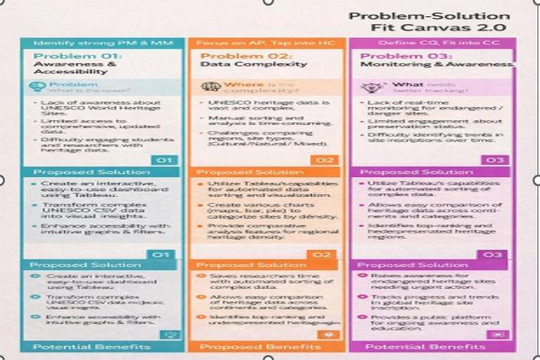

[Problem solution fit canvas link URL here](https://drive.google.com/file/d/1OiOl2tVFMjd2OqJ9XWdTqtv8zx2_jgnF/view?usp=sharing)

**4.2 Proposed Solution**

**Proposed Solution :**

|  |  |  |
| --- | --- | --- |
| **S.No** | **parameter** | **Discription** |
| **1.** | Problem Statement (Problem to be solved) | Many users lack a clear, centralized view of UNESCO heritage sites across countries and regions. Existing data is scattered and difficult to analyze for trends, comparisons, and endangered sites. |
| **2.** | Idea / Solution description | The solution uses Tableau dashboards to visualize UNESCO Heritage data. It helps users explore sites by country, region, category, and year through interactive charts and maps. |
| **3.** | Novelty / Uniqueness | The project combines global heritage data with interactive visual analytics. Unlike static reports, it provides dynamic insights using maps, filters, and trend analysis. |
| **4.** | Social Impact / Customer Satisfaction | This project increases awareness about cultural and natural heritage sites and highlights endangered locations. It supports education, research, and heritage conservation efforts. |
| **5.** | Business Model (Revenue Model) | The dashboard can be used by educational institutions, researchers, and tourism organizations. It can support data-driven decision-making and heritage studies. |
| **6.** | Scalability of the Solution | The solution is scalable and can be extended by adding new datasets, more countries, or future UNESCO site updates without redesigning the dashboard. |

**4.3 Solution Architecture**

The solution architecture of the Heritage Treasures project is designed to provide meaningful visual analytics using Tableau. The process starts with a UNESCO heritage dataset containing information such as site name, country, region, category (Cultural, Natural, Mixed), year of inscription, and endangered status.

The dataset is cleaned and prepared by handling missing values, standardizing fields, and filtering required attributes. The processed data is then used to create multiple visualizations such as world maps, bar charts, trend graphs, and comparison charts, which are organized into interactive dashboards.

Users can interact with the dashboards using filters for region, country, category, and year to explore heritage site distribution and trends. Finally, the dashboards are published on Tableau Public and shared using public URLs, enabling easy access and data-driven insights into global heritage sites.

The solution architecture helps bridge the gap between raw heritage data and meaningful insights. Its goals are to:

* Provide a clear visualization-based understanding of UNESCO heritage data.
* Enable comparison and trend analysis across regions and countries.
* Support awareness and decision-making related to heritage conservation.

**5. PROJECT PLANNING & SCHEDULING**

**5.1 Project Planning**

**Product Backlog, Sprint Schedule, and Estimation**

| **Sprint** | **Functional Requirement (Epic)** | **User Story Number** | **User Story / Task** | **Story Points** | **Priority** | **Team Members** |
| --- | --- | --- | --- | --- | --- | --- |
| Sprint-1 | |  | | --- | | Data Collection |  |  | | --- | |  | | USN-1 | |  | | --- | | As a team, we collect relevant UNESCO heritage site data from public sources |  |  | | --- | |  | | 2 | High | Harini Jajula  Tadi Satya prasanna |
| Sprint-1 | |  | | --- | | Data Preparation |  |  | | --- | |  | | USN-2 | |  | | --- | | As a team, we load and organize the collected data | | 1 | High | Chitturi Shanmuja  Suravarapu Kushal |
| Sprint-2 | |  | | --- | | Data Preprocessing | | USN-3 | |  | | --- | | As a team, we clean missing values in the dataset | | 3 | High | Chitturi Shanmuja  Suravarapu Kushal |
| Sprint-1 | |  | | --- | | Data Preprocessing |  |  | | --- | |  | | USN-4 | |  | | --- | | As a team, we handle categorical data for analysis |  |  | | --- | |  | | 2 | Medium | Harini Jajula  Tadi Satya prasanna |
| Sprint-2 | |  | | --- | | Model & Insights |  |  | | --- | |  | | USN-5 | |  | | --- | | As a team, we build the Tableau dashboards |  |  | | --- | |  | | 5 | High | Harini Jajula  Tadi Satya prasanna |
| Sprint-2 | |  | | --- | | Model & Insights | | |  | | --- | | USN-6 | | |  | | --- | | As a team, we test the dashboards and validate insights | | 3 | High | Chitturi Shanmuja  Suravarapu Kushal |
| |  | | --- | | Sprint-2 |  |  | | --- | |  | | |  | | --- | | Deployment |  |  | | --- | |  | | |  | | --- | | USN-7 |  |  | | --- | |  | | |  | | --- | | As a team, we design working HTML pages for embedding |  |  | | --- | |  | | 3 | |  | | --- | | Medium |  |  | | --- | |  | | Harini Jajula  Tadi Satya prasanna |
| |  | | --- | | Sprint-2 |  |  | | --- | |  | | |  | | --- | | Deployment |  |  | | --- | |  | | |  | | --- | | USN-8 |  |  | | --- | |  | | |  | | --- | | As a team, we deploy the dashboards online using Flask |  |  | | --- | |  | | 5 | High | Chitturi Shanmuja  Suravarapu Kushal |

**Total Story Points:**  
Sprint-1: 8  
Sprint-2: 16  
Total: 24

**Project Tracker, Velocity & Burndown Chart: (4 Marks)**

| **Sprint** | **Total Story Points** | **Duration** | **Sprint Start Date** | **Sprint End Date (Planned)** | **Story Points Completed (as on Planned End Date)** | **Sprint Release Date (Actual)** |
| --- | --- | --- | --- | --- | --- | --- |
| Sprint-1 | |  | | --- | |  |  |  | | --- | | 8 | | |  | | --- | | 5 Days |  |  | | --- | |  | | 10 Feb 2026 | |  | | --- | | 15 Feb 2026 |  |  | | --- | |  | | 8 | |  |  | | --- | --- | | |  | | --- | |  | |  |  |  | | --- | --- | |  | 15 Feb 2026 | |
| Sprint-2 | |  | | --- | |  |  |  | | --- | | 16 | | |  | | --- | | 5 Days |  |  | | --- | |  | | |  | | --- | | 16 Feb 2026 |  |  | | --- | |  | | |  | | --- | | 20 Feb 2026 |  |  | | --- | |  | | 16 | 27 Feb 2026 |

**Velocity:**Total Story Points = 24  
Number of Sprints = 2Velocity = 24 / 2 = 12 Story Points per Sprint

**Average Velocity per Day:**Sprint Duration = 5 Days  
Velocity per Day = 8 / 5 = 1.6 Story Points per Day

**Burndown Chart:**

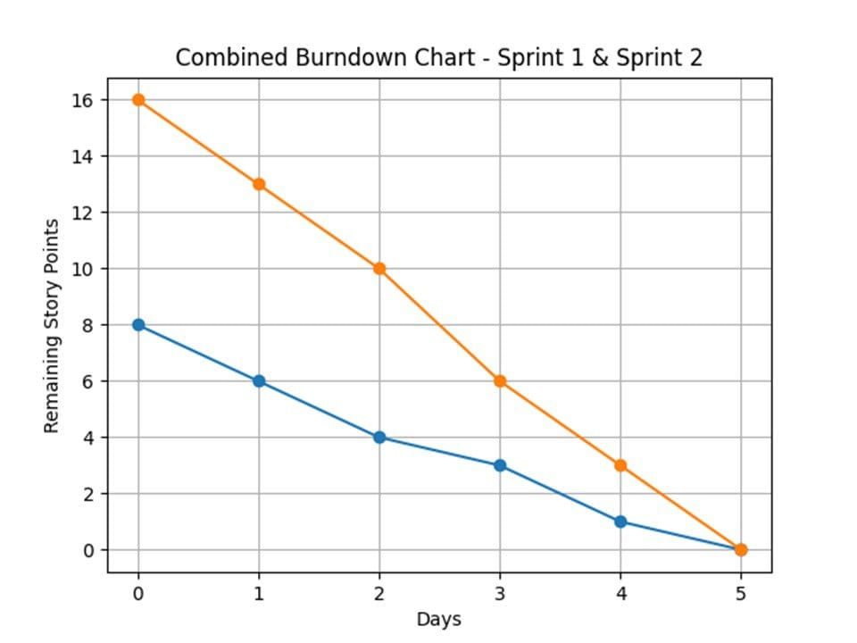

**6. FUNCTIONAL AND PERFORMANCE TESTING**

**6.1 Performance Testing**

**1. Data Rendered:**

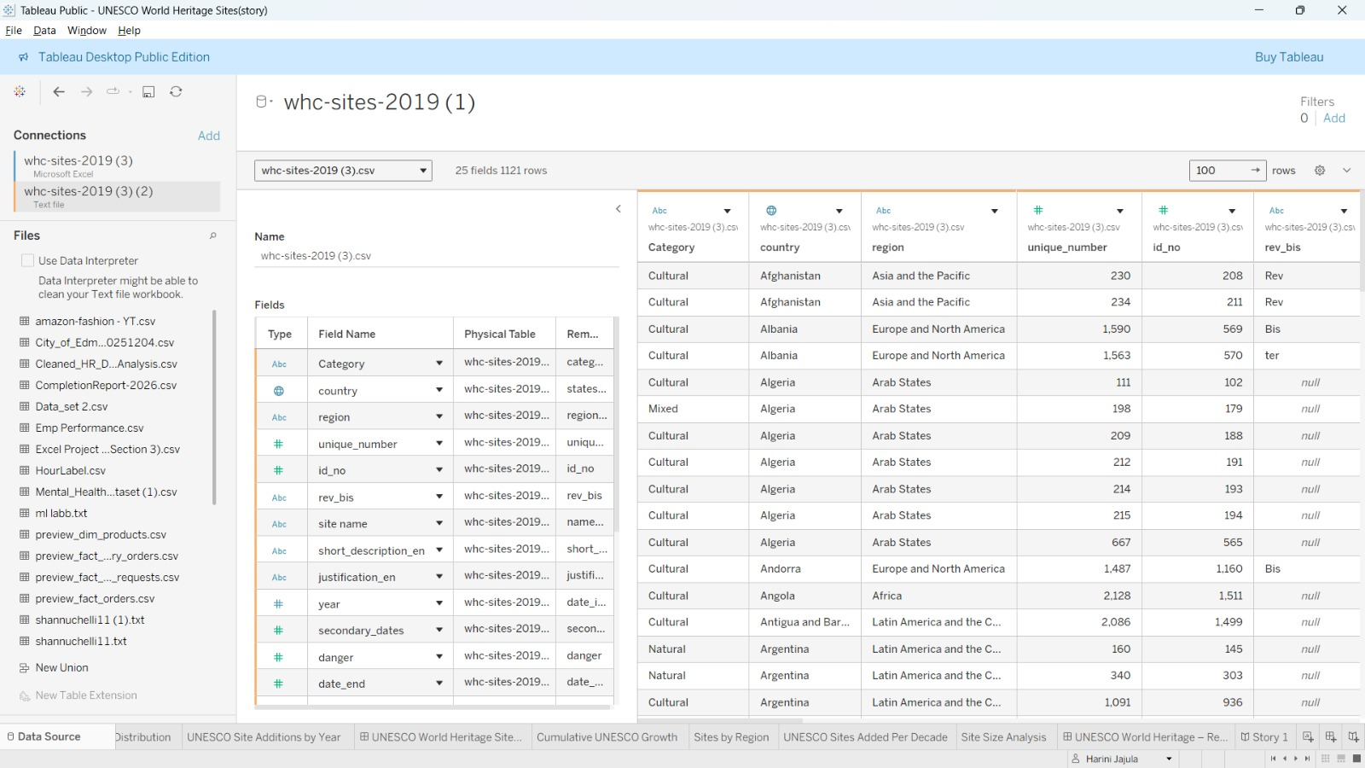

**2.Data preprocessing:**



**3. utilization of filters**

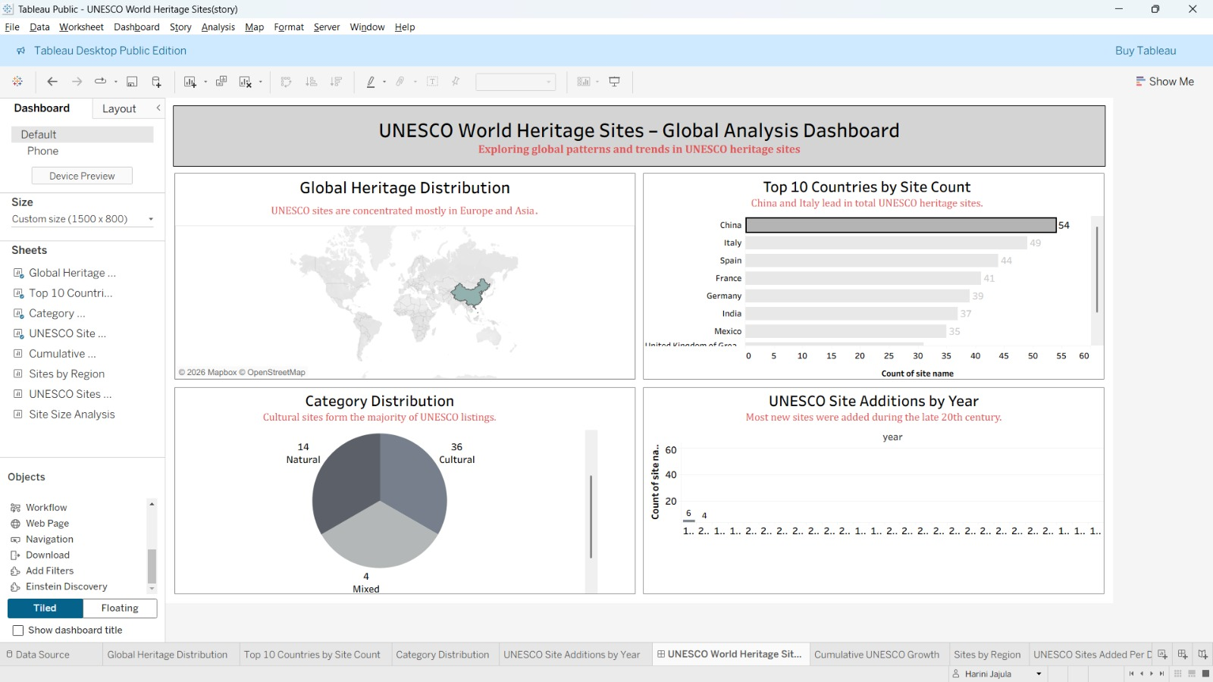

**4.Calculated field:**

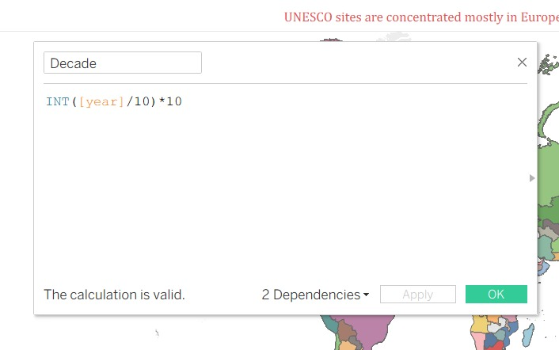

**5.Dashboards:**

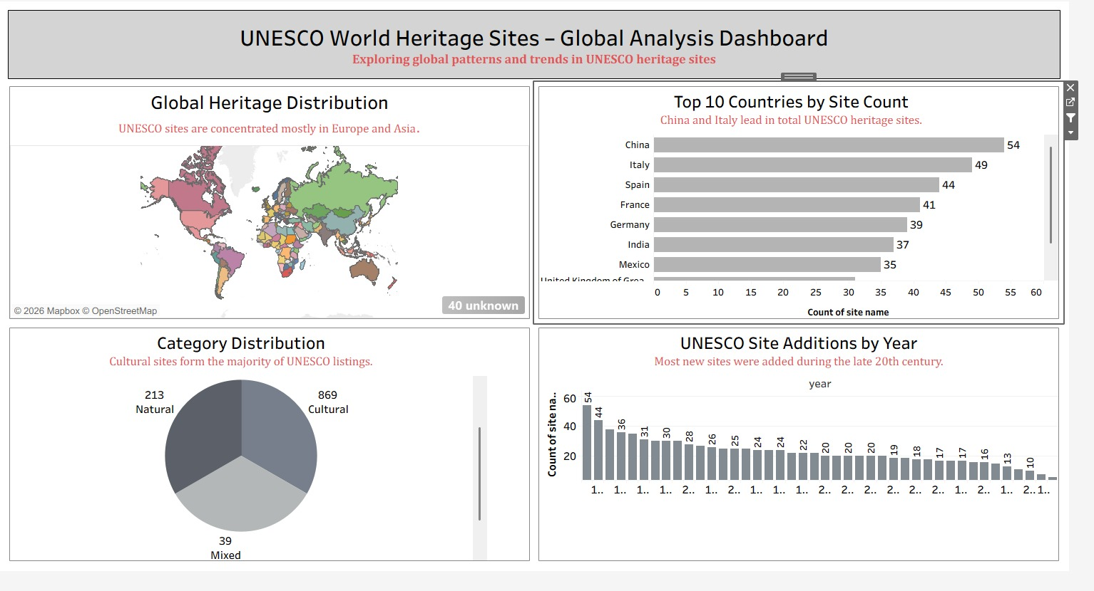

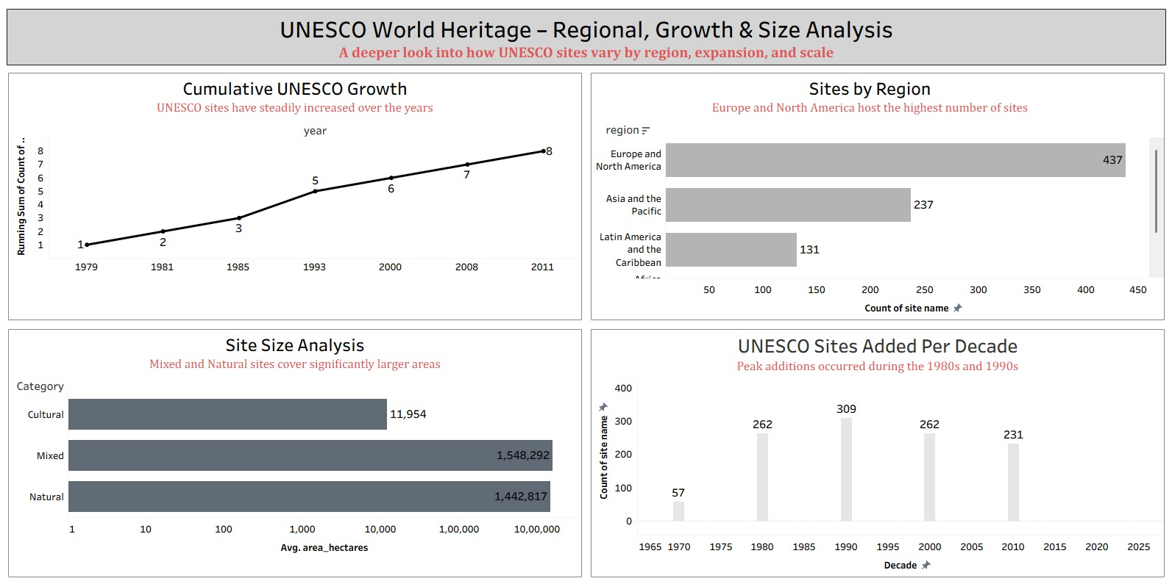

**6. Story Telling:**

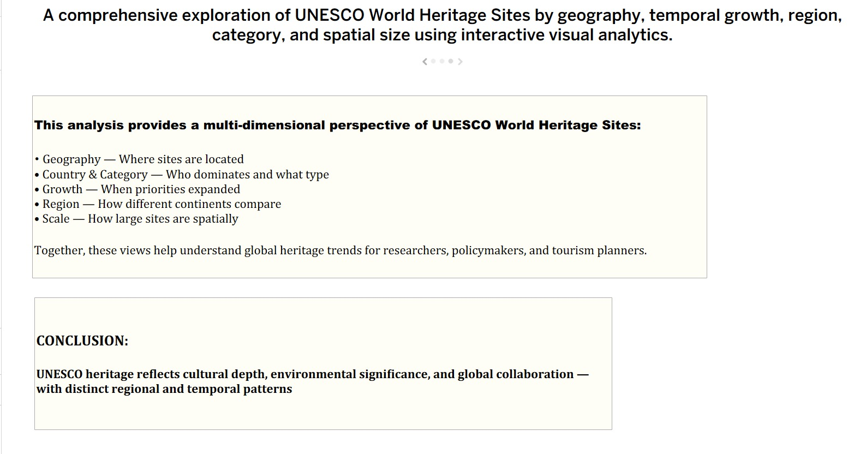

**7. RESULTS**

**7.1 Output Screenshots**

**Activity 1.1: Global Heritage Distribution**

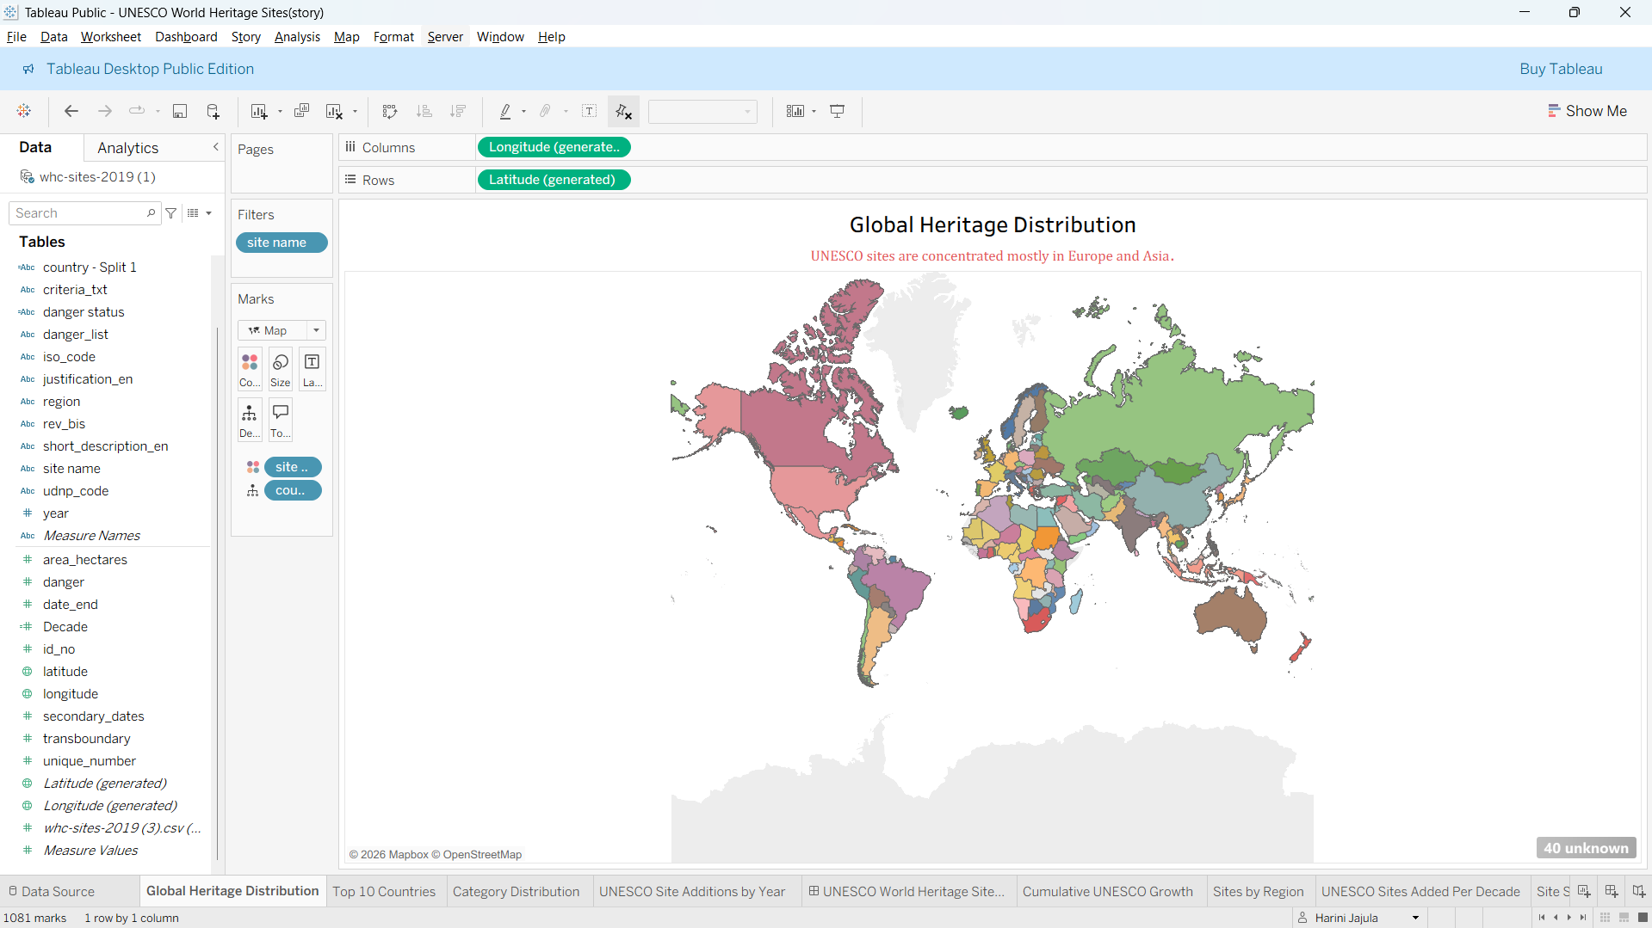

**Activity 1.2: Top 10 Countries by Site Count**

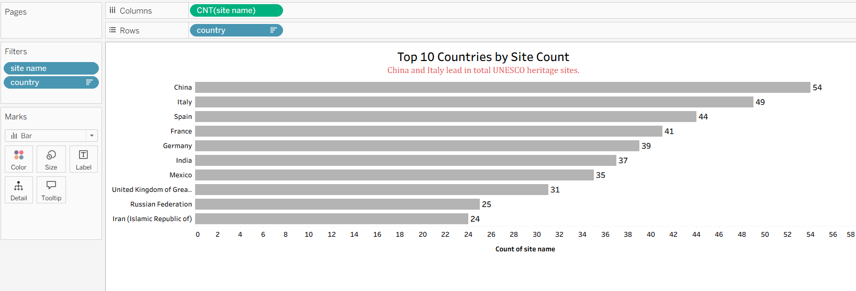

**Activity 1.3:  Category Distribution**

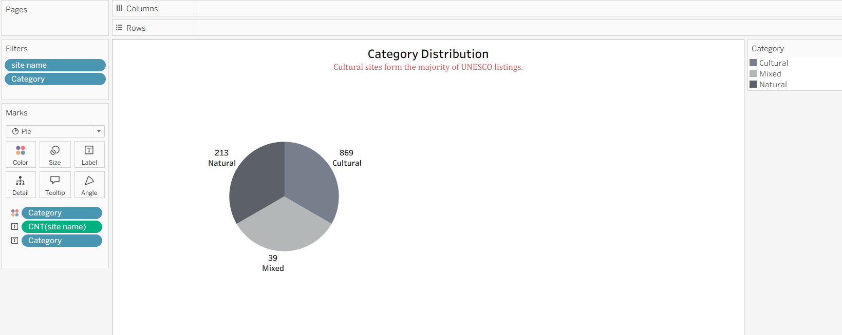

**Activity 1.4 : UNESCO Site Additions by Year**

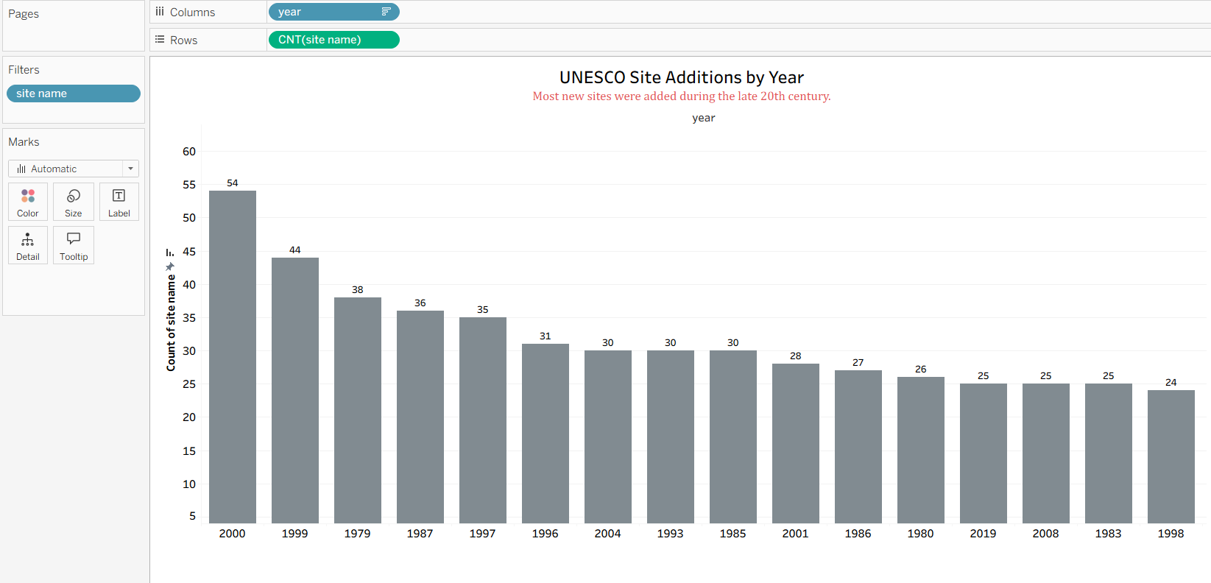

**Activity 1.5 : Cumulative UNESCO Growth**

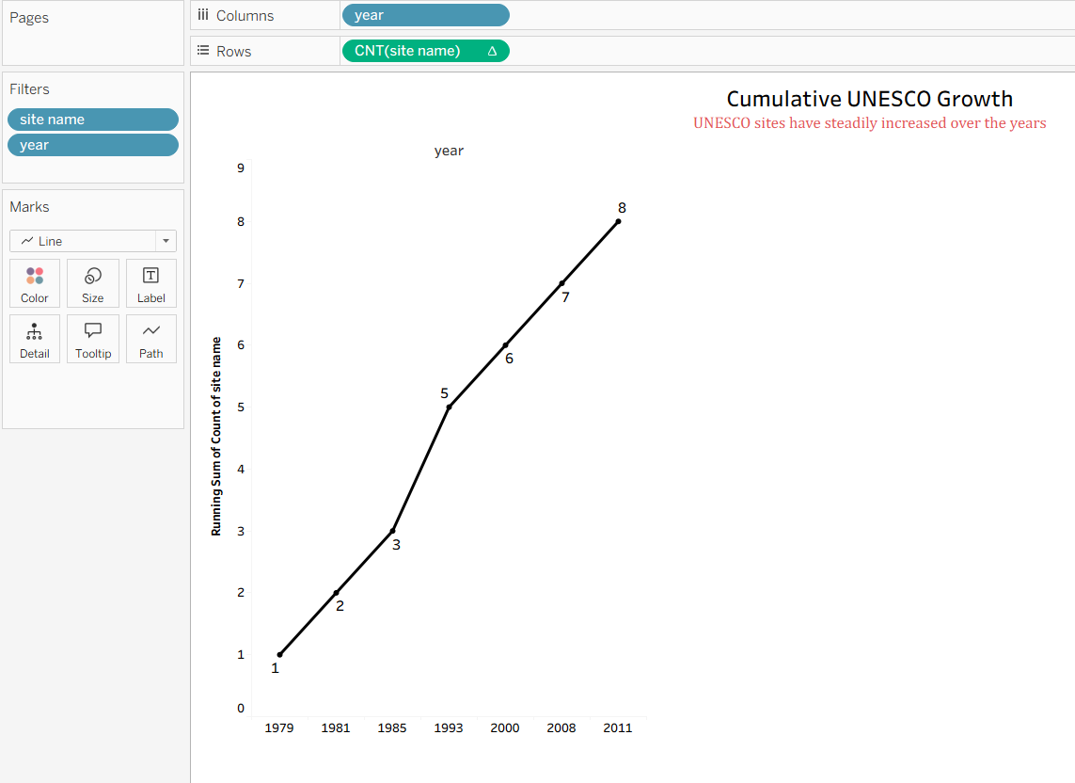

**Activity 1.6 : Sites by Region**

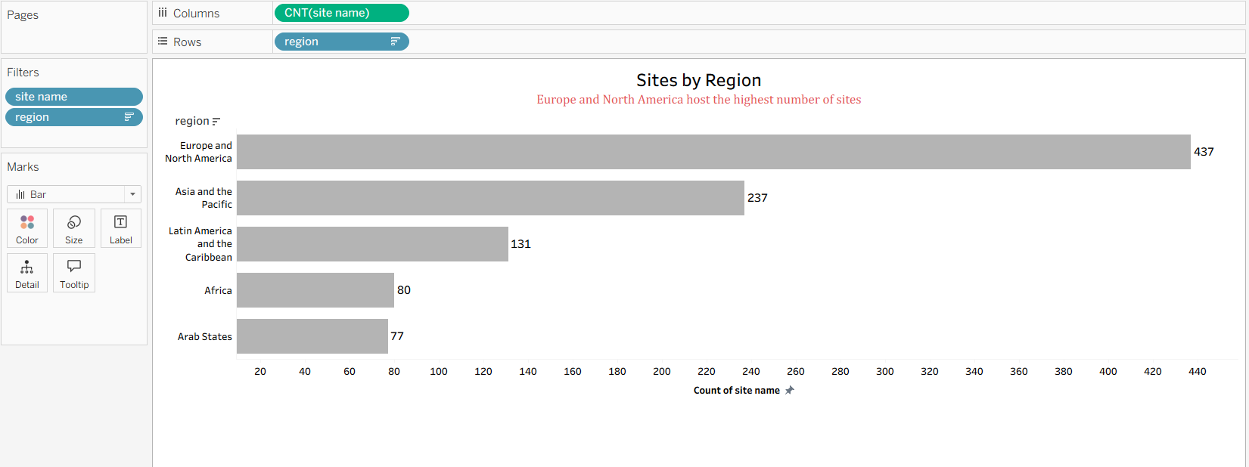

**Activity 1.7 : UNESCO Sites Added Per Decade**

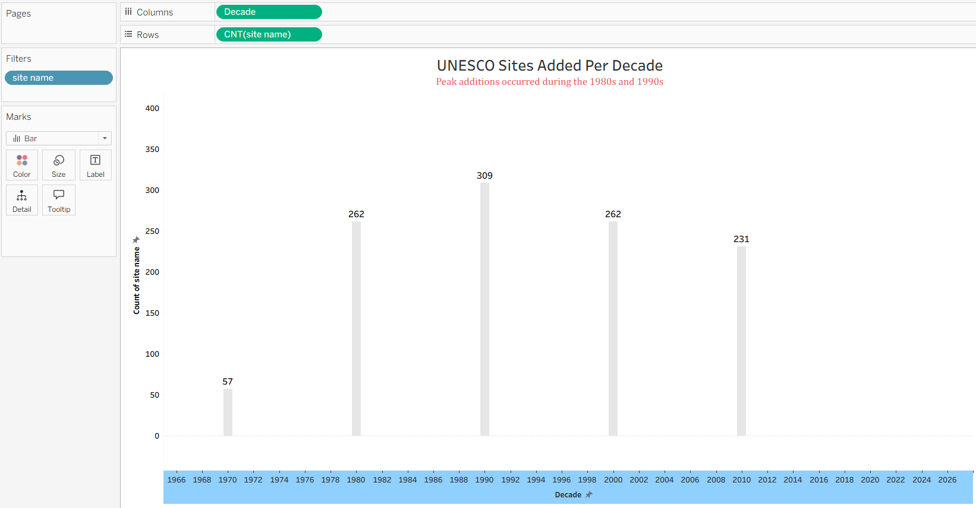

**Activity 1.8 : Site Size Analysis**

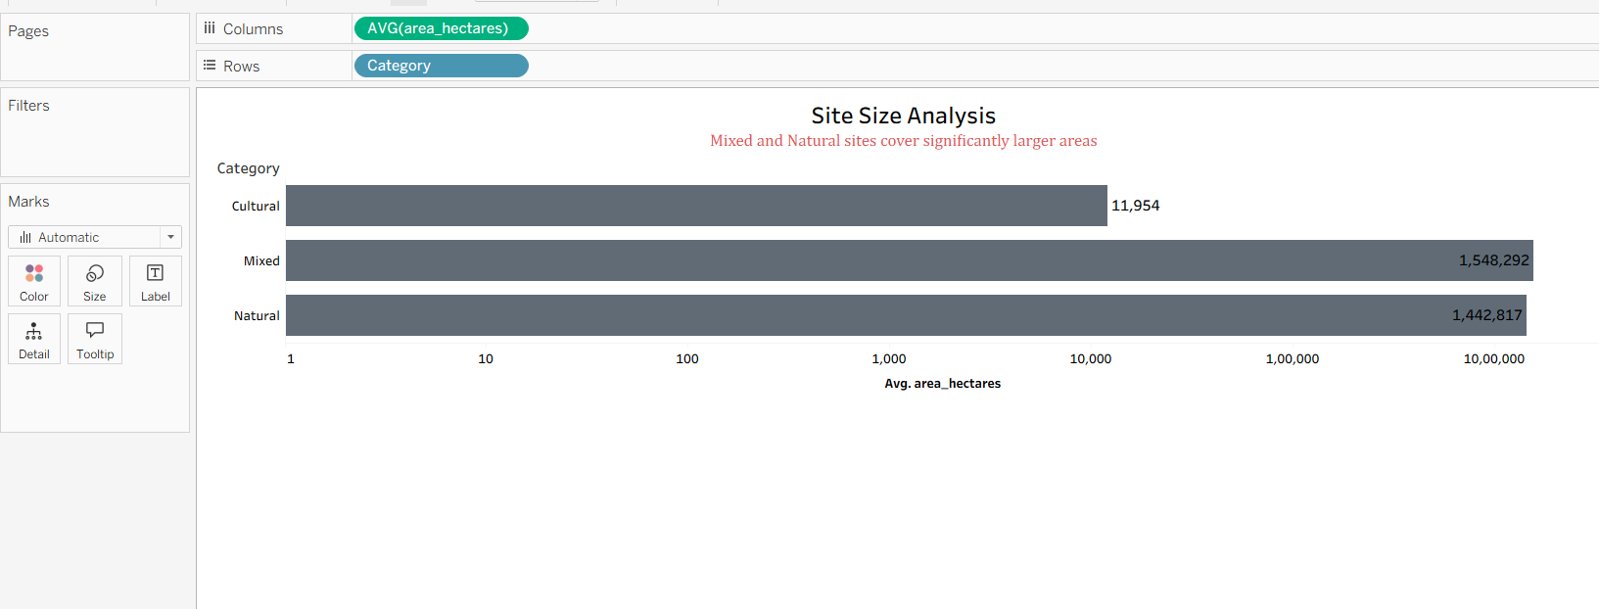

**Activity 1.9 : UNESCO World Heritage Explorer**

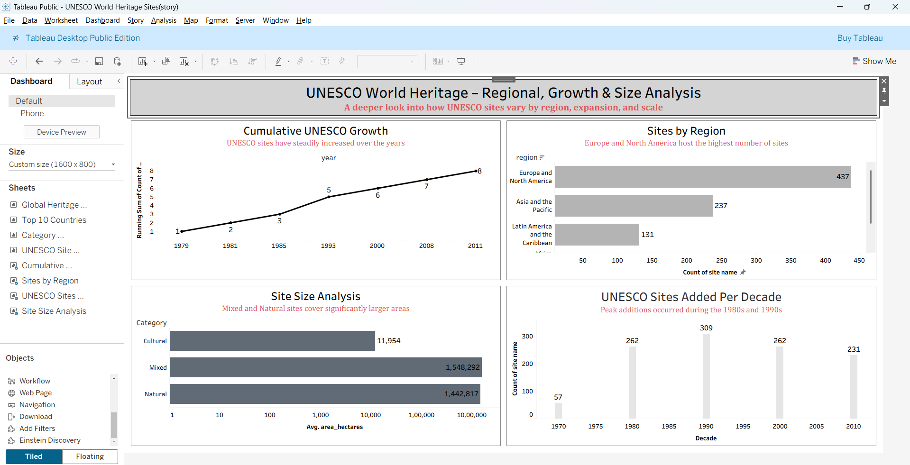

**Responsive and Design of Dashboard : Heritage Treasures and Detailed Analysis**

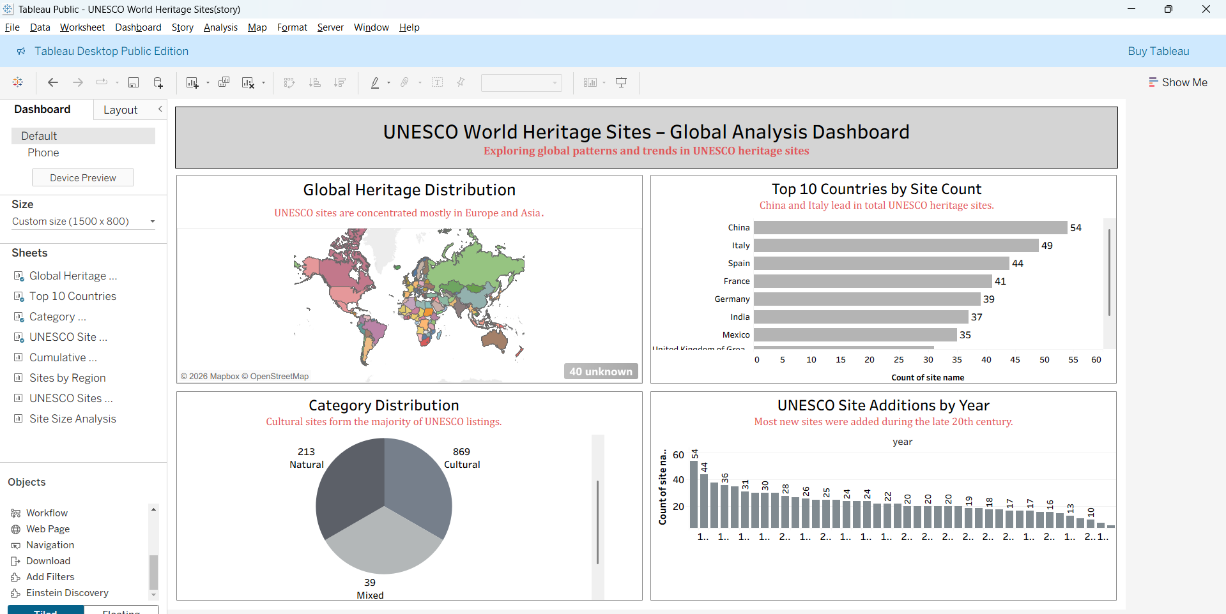

**Heritage Treasures :Suitability Overview**



**8. ADVANTAGES & DISADVANTAGES**

**Here is a detailed breakdown of the advantages and disadvantages of using Data Analytics with Tableau Heritage Treasures: An In-Depth Analysis of UNESCO World Heritage Sites using Tableau**

**Advantages of Heritage Treasures with Tableau**

|  |  |
| --- | --- |
| **Advantage** | **Description** |
| **1. Interactive Visualization** | **Using Tableau enables dynamic dashboards that make complex heritage data from UNESCO easy to explore and understand.** |
| **2. Data-Driven Insights** | **The project supports informed decision-making by identifying trends, regional distributions, and growth patterns of World Heritage Sites.** |
| **3. User-Friendly Interface** | **Intuitive design and interactive filters allow users from non-technical backgrounds to analyze data efficiently.** |
| **4. Scalability** | **The data model can be easily updated with new heritage site inscriptions without major structural changes.** |
| **5.Comprehensive Global Overview** | **Provides a consolidated analysis of World Heritage Sites recognized by UNESCO in a single interactive platform.** |
| **6. Advanced Data Visualization** | **Utilizes powerful features of Tableau such as maps, trend lines, filters, and calculated fields for deeper insights.** |
| **7. Improved Analytical Efficiency** | **Reduces manual data analysis time by automating calculations and visual representations.** |
| **8. Enhanced Comparative Analysis** | **Enables easy comparison between countries, continents, and heritage categories (Cultural, Natural, Mixed).** |
| **9. Better Strategic Planning** | **Helps policymakers and tourism authorities identify growth opportunities and underrepresented regions.** |
| **10. Customizable Dashboards** | **Users can personalize views using filters and parameters according to their analytical needs.** |

**Disadvantages of Heritage Treasures with Tableau**

|  |  |
| --- | --- |
| **Disadvantage** | **Description** |
| **1. Data Dependency** | **The accuracy of insights depends entirely on the completeness and correctness of the available UNESCO dataset.** |
| **2. Performance Limitations** | **Large datasets may affect dashboard performance if not optimized properly.** |
| **3. Limited Real-Time Updates** | **If static datasets are used, the analysis may not reflect the most recent heritage site additions.** |
| **4. Software Dependency** | **The project relies heavily on Tableau, which may require licensing costs and technical familiarity.** |
| **5. Data Quality Constraints** | **Incomplete or outdated data may lead to misleading interpretations.** |
| **6. Technical Learning Curve** | **Users may require basic training to fully utilize advanced Tableau features.** |

**9. CONCLUSION**

**T**he project *“*Heritage Treasures: An In-Depth Analysis of UNESCO World Heritage Sites using Tableau*”* successfully demonstrates how data analytics can transform complex global heritage data into meaningful insights. By leveraging Tableau, the study consolidates information from UNESCO and presents it in an interactive, visually engaging format. Users can explore trends, regional distributions, and the growth of Cultural, Natural, and Mixed heritage sites with ease, enabling a deeper understanding of the world’s heritage landscape.

Operational efficiency was a key achievement of the project. Through proper data cleaning, structured modeling, and optimized dashboard performance, the analysis process was streamlined, reducing manual intervention and improving accuracy. The use of reusable calculations, dynamic filters, and parameters ensured that the system could adapt to new data seamlessly, allowing stakeholders to maintain a high level of performance without extensive technical effort.

The project also enhanced the user experience by focusing on intuitive design and interactive exploration. Clear visual storytelling, drill-down features, and personalized dashboards allowed users—including researchers, policymakers, and tourism planners—to extract insights efficiently. This approach not only supports informed decision-making but also strengthens engagement with the data, making global heritage information accessible to diverse audiences.

Finally, the project highlights both the potential and limitations of using data analytics for heritage studies. While it enables data-driven decision-making, strategic resource allocation, and tourism growth, it also depends on data quality and requires technical familiarity with Tableau for full utilization. Despite these challenges, *Heritage Treasures* demonstrates a scalable, efficient, and insightful framework for analyzing UNESCO World Heritage Sites, proving that data analytics can play a crucial role in preserving, promoting, and understanding the world’s most treasured cultural and natural landmarks.

**10. FUTURE SCOPE**

The Heritage Treasures project has the potential to evolve further by incorporating advanced analytics, real-time updates, and interactive features. Here is the future scope of such systems, especially when integrated with platforms like Tableau:

**1.AI & Predictive Analytics**

**Future Vision:** Use of AI and machine learning to predict tourism trends, visitor influx, and site conservation risks.**Impact:** Enables proactive planning for infrastructure, conservation, and targeted tourism campaigns.

**2.Automation & Smart Workflows**

**Future Vision:** Greater automation in data updates, reporting, and alerting for newly inscribed heritage sites.**Impact:** Reduces manual effort, ensures timely insights, and improves decision-making efficiency.

**3.Integration with IoT & Smart Devices**

**Future Vision:** Real-time monitoring of visitor flow, site conditions, and environmental factors using IoT devices.**Impact:** Enhances site preservation, safety, and visitor experience through timely alerts and data collection.

**4.Hyper-Personalization of Insights**

**Future Vision:** Advanced dashboards that customize insights based on user roles—researchers, policymakers, or tourism planners.**Impact:** Delivers relevant, actionable information to diverse stakeholders for informed decision-making.

**5.Enhanced Global Data Connectivity**

**Future Vision:** Seamless integration with international tourism, conservation, and UNESCO databases for comprehensive analysis.**Impact:** Provides a unified view of global heritage, enabling cross-country comparisons and collaborative initiatives.

**6.Improved Cybersecurity & Data Compliance**

**Future Vision:** AI-powered security measures to protect sensitive site and visitor data, with compliance monitoring.**Impact:** Ensures data privacy, protects against breaches, and adheres to governance regulations.

**.Mobile-First Experience**

**Future Vision:** Fully interactive mobile dashboards for stakeholders and tourists to explore heritage data on-the-go.**Impact:** Increases accessibility, engagement, and real-time decision-making from any location.

**8.Sustainability & Environmental Monitoring**

**Future Vision:** Integration with tools to track environmental impact, site degradation, and conservation metrics. **Impact:** Supports eco-friendly tourism, preservation efforts, and long-term sustainability of heritage sites

**Conclusion Future Scope**

The future scope of the Heritage Treasures project highlights its potential to evolve into a more intelligent, interactive, and sustainable platform for heritage management and tourism planning. By integrating AI, predictive analytics, IoT monitoring, and mobile accessibility, the system can provide real-time insights, personalized recommendations, and proactive conservation strategies.

These advancements will not only improve operational efficiency and stakeholder decision-making but also enhance visitor engagement and global collaboration for heritage preservation. With continued innovation, the project can serve as a comprehensive, scalable, and forward-looking tool to protect, promote, and analyze UNESCO World Heritage Sites worldwide. In the future ,this project can be enhanced by integrating additional real-time data sources,advanced analytics, and predictive models and support decision making for heritage conservation and tourism planning it successfully demonstrates the use of data visualization techniques to analyze UNESCO World Heritage sites through interactive tableau dashboards integrated.with a Flask web application the project provides meaningful insights into heritage site distribution ,categories ,regions,and endangered sites to explore data in an intuitive

**11. Deployment of Flask Web Application with Embedded Tableau Dashboard**

**11.1 Overview**

This section describes the deployment and execution process of the developed Flask web application that embeds interactive Tableau Public dashboards. The application was designed to present insights related to UNESCO World Heritage Sites by integrating multiple Tableau dashboards and a story view into a single web interface. The Flask framework was used to serve the web application locally, allowing users to access and interact with the visualizations through a browser-based interface

**11.2 Hosting Platform**

The Flask web application was executed on a local development environment using Python. The purpose of choosing a local hosting approach was to demonstrate the working of Flask-based web integration without relying on external cloud deployment platforms. This setup enabled quick testing, easy debugging, and seamless integration of Tableau Public dashboards using web embedding techniques.

**11.3 Project Structure**

The Flask application was structured in a modular manner to support clean separation of logic and presentation. The main application logic was implemented in the app.py file, which handles routing and renders the HTML template. The templates folder contains the index.html file, which embeds Tableau dashboards and the story using iframe-based integration. This structure follows standard Flask conventions and ensures maintainability and clarity of the project.

**11.4 Key Configuration Files**

The core configuration of the application resides in the app.py file, where Flask is initialized and the home route is defined. The HTML file embedded within the templates directory contains the Tableau Public links for Dashboard 1, Dashboard 2, and the Story view. These links enable the rendering of interactive visualizations directly within the Flask application interface. The app.py file initializes the Flask framework and defines the main route responsible for loading the web interface. The index.html file located in the templates directory embeds Tableau Public dashboards and the story using iframe-based integration.

**11.5 Deployment Process**

Initially, Python and the Flask framework were installed and configured on the system. The Flask application was created to serve a web page containing embedded Tableau dashboards. Tableau Public dashboards and a story were integrated into the application using iframe web integration. After configuring the application files, the Flask development server was started using the command python app.py. Once the server was running, the application was successfully accessed through the local URL http://127.0.0.1:5000, where all embedded visualizations were rendered correctly.

**11.6 Issue Encountered and Resolution**

During the initial execution of the application, the embedded Tableau visualizations did not load as expected due to incorrect or incomplete embed URLs. This issue was resolved by verifying and updating the Tableau Public links for each dashboard and the story. After correcting the embed URLs, the dashboards loaded successfully within the Flask web application.

**11.7 Final Result**

The final outcome of the project is a fully functional Flask web application that successfully integrates two Tableau dashboards and one Tableau story into a single interface. Users can interact with the visualizations to explore UNESCO World Heritage data effectively. The project demonstrates the successful integration of data visualization tools with a Python-based web framework, providing an interactive and user-friendly analytical platform. The application enables users to interactively explore UNESCO World Heritage data, including insights related to categories, regions, endangered sites, and site area distribution. By embedding Tableau Public visualizations using HTML iframes within the Flask framework, the project demonstrates seamless web integration of data visualization tools with Python. The dashboards and story load correctly through the Flask server and provide an intuitive, user-friendly analytical experience. Overall, the project highlights the effectiveness of Flask as a lightweight web framework for hosting and integrating interactive visual analytics, making the system suitable for academic analysis and future real-world extensions. The successful execution of this project confirms its readiness for academic evaluation and demonstrates its potential for further enhancement with advanced analytics, authentication, or cloud-based deployment.

This platform with a python-based web technologies.The project showcase how interactive visual analytics developed advanced interactive and scalable data-driven web applications

**All Links**

**Data set :**  [**Data Set Link**](https://www.kaggle.com/datasets/ujwalkandi/unesco-world-heritage-sites/data?select=whc-sites-2019.csv)

**Heritage Treasures**  **:** [**Tableau Public Dashboard Link**](https://public.tableau.com/app/profile/harini.jajula/viz/UNESCOWorldHeritageSites1_17722746450000/UNESCOWorldHeritageSitesGlobalAnalysisDashboard?publish=yes) **1 (Overview)**

**Heritage Treasures :** [**Tableau Public Dashbord Link 2**](https://public.tableau.com/app/profile/harini.jajula/viz/UNESCOWorldHeritageSites2/UNESCOWorldHeritageRegionalGrowthSizeAnalysis) **(Danger Site Analysis)**

**Tableau Public Story Link :** [**Tableau Public Story Link**](https://public.tableau.com/app/profile/rokalla.likhitha/viz/UNESCOWorldHeritageSites11/Story1?publish=yes)

**Web Integration Using Flask :** [**Web Integration Link**](https://harini475.github.io/unesco-project/)

**Project Demo Live link : Heritage Treasures**  ( wait 2 mins loading takes time)